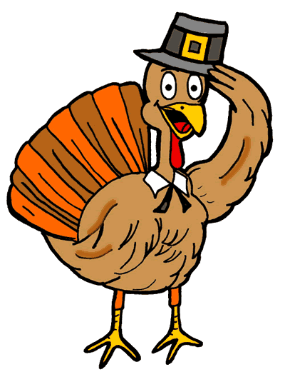

Thanksgiving Dinner Special

12 Lbs. Roasted Turkey or 3 Roasted Chickens
- 2 Lbs. Brisket of Beef Dinner Style (w/o $185 + tax)
- 4 Qt. Chicken Noodle Soup
- 16 Lg. Matzo Balls
- 1 Lg. Mushroom Herb Stuffing Tray
- 3 Lbs. Vegetable Medley
- 2 Lbs. Chopped Liver
- 1 Qt. Cranberry Nut Relish
- 1 Lg. Sweet Potato Pudding Tray
- 3 Lbs. Your Choice Kasha Varnishkes, Egg Barley & Mushroom or butternut squash
- 2 Qts. Gravy
- 1 Dz. Dinner Rolls
$220 + Tax
FEEDS 10-12 People
~Please, No Substitutions~
All Orders Must Be In By November 16th
51 West Allendale Ave, Allendale NJ 07401
201-995-1204

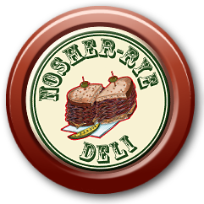
NOSHER RYE NEW YORK STYLE
DELICATESSEN

Thanksgiving Catering Menu
(201)-995-1204
Qty. Price
 | Thanksgiving Family Dinner (Feeds 10-12) | $220 + tax
 | Thanksgiving Family Dinner w/o Brisket (Feeds 10) | $185 + tax

QTY | SOUPS & STARTERS | PRICE
 | Matzo Balls (package of 6) | $6.99
 | Clear Chicken Soup | $6.99 qt.
 | Chicken Noodle Soup | $6.99 qt.
 | Mushroom and Barley Soup | $6.99 qt.
 | Salt & Pepper Gifilte Fish | $2.50 ea.
 | Sweet Gefilte Fish (Loaf aprox. 1 ½ lbs) | $16.95 ea.
 | Salmon Gefilte Fish | $17.95 ea.
 | Mini Stuffed Cabbage (package of 6) | $12.00 pkg.
 | Chopped Liver | $10.99 lb.
 | Vegetable Chopped Liver | $9.99 lb.
 | Kreplach (package of 6) | $8.99 pkg.

QTY | ENTREES | PRICE
 | Roasted Chicken (1/4) | $10.99 ea.
 | Cranberry Chicken (1/2) | $6.99 lb.
 | Garlic & Rosemary Chicken (1/2) | $6.99 lb.
 | Brisket of Beef w/ Gravy | $17.95 lb.
 | Roasted Turkey Whole w/ Gravy | $4.99 lb.
 | Orange Glazed Cornish Hens | $10.99 ea.
 | Breaded Chicken Cutlets | $10.99 lb.
 | Large Turkey Stuffed Cabbage | $5.95 ea.
 | Large Beef Stuffed Cabbage | $5.95 ea.
 | Turkey Meatloaf | $6.49 lb.
 | Beef Meatloaf | $6.49 lb.
 | Chicken Marsala Tray (feeds 10-12 people) | $55.00 tray
 | Chicken Francese Tray (feeds 10-12 people) | $55.00 tray
 | Fresh White Meat Turkey Sliced | 16.95 lb.

QTY | SIDE DISHES | PRICE
 | Broccoli Soufflé Tray (feeds aprox. 8 people) | $12.99 tray
 | Spinach Soufflé Tray (feeds aprox. 8 people) | $12.99 tray
 | Noodle Pudding Tray (feeds aprox. 8 people) | $12.99 tray
 | Potato Pudding (feeds aprox. 8 people) | $12.99 tray
 | Sweet Potato Pudding Tray (feeds aprox. 8 people) | $12.99 tray
 | Bread & Herb Stuffing (feeds aprox. 8 people) | $12.99 tray
 | Homemade Mashed Potatoes | $3.99 lb.
 | Roasted Potatoes / Sweet Potatoes | $5.69 lb.
 | Potato Pancake | $3.50 ea.
 | Beef Gravy | $4.75 qt.
 | Turkey Gravy | $4.75 qt.
 | Stuffed Derma w/ Gravy | $8.95 lb.
 | Glazed Baby Carrots | $6.50 lb.
 | Broccoli w/ Garlic Sauce | $6.50 lb.
 | String Beans Almondine | $6.99 lb.
 | Grilled Veggies | $7.99 lb.
 | Kasha Varnishkes | $5.69 lb.
 | Egg Barley & Mushroom | $5.69 lb.
 | Israeli Salad | $7.99 lb.
 | Health Salad | $4.99 lb.
 | Cucumber Salad | $4.99 lb.
 | Snow Peas | $7.99 lb.
 | Cole Slaw | $3.99 lb.

QTY | CAKES & CHALLAHS | PRICE
 | Plain Challah | $4.99 ea.
 | Raisin Challah | $4.99 ea.
 | Challah Rolls (pkg of 6) | $4.99 pkg.
 | Rugelach (assorted) | $16.95 lb.
ALL ORDERS MUST BE PLACED BY 11/16!

Last Name:_______________________ Phone:_________________

Pickup Day: Thurs 11/22 (must be picked up by 12:00pm)

51 West Allendale Road, Allendale NJ 07401
201-995-1204

Have a Happy Holiday!

